Chapter 19, Problem 8.

Find the z parameters of the two-port in Fig. 19.72.

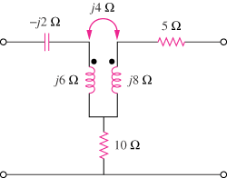

Figure 19.72
For Prob. 19.8.

